SELENIUM TESTING

**On Lakshya Holding**

| **Submitted By:** | **Submitted To:** |
| --- | --- |
| **Nischal Shrestha** | **Prajesh Shakya** |

**Date: 13th June, 2025**

# TABLE OF CONTENTS

**TABLE OF CONTENTS 2**

**LAKSHYA HOLDING 3**

Test Environment 3

Tests on Lakshya Holding Revamp 3

1. Website opens in different browsers 3

2. Page Title 4

3. Navbar Navigation 6

# 

# LAKSHYA HOLDING

## Test Environment

| URL | [Lakshya Holdings](https://lakshyaholdings.techarttrekkies.com.np/) |
| --- | --- |
| Eclipse Version | 4.35.0 |
| Operating System | Windows 10 Pro, Version 22H2 |
| Browser | Chrome 137.0.7151.104  Edge 137.0.3296.83 |
| Java Version | 17.0.12 2024-07-16 LTS |

## Tests on Lakshya Holding Revamp

### Website opens in different browsers

#### Code:

import org.openqa.selenium.chrome.ChromeDriver;

import org.openqa.selenium.edge.EdgeDriver;

public class BrowserDriver {

public static void main(String[] args) {

ChromeDriver driver = new ChromeDriver();

driver.get("https://lakshyaholdings.techarttrekkies.com.np/");

EdgeDriver driver1 = new EdgeDriver(); // Use EdgeDriver

driver1.get("https://lakshyaholdings.techarttrekkies.com.np/");

}

}

#### Output:

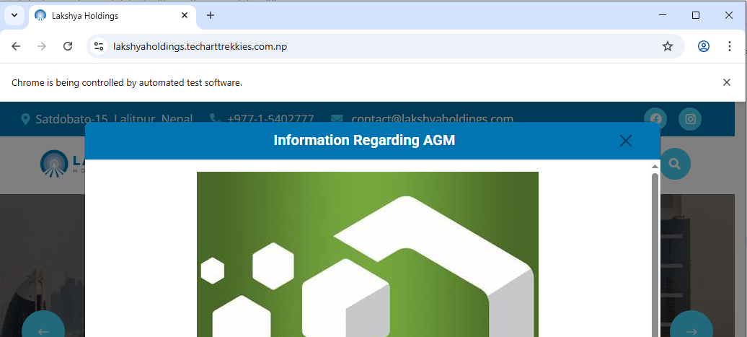

Fig: ChromeDriver

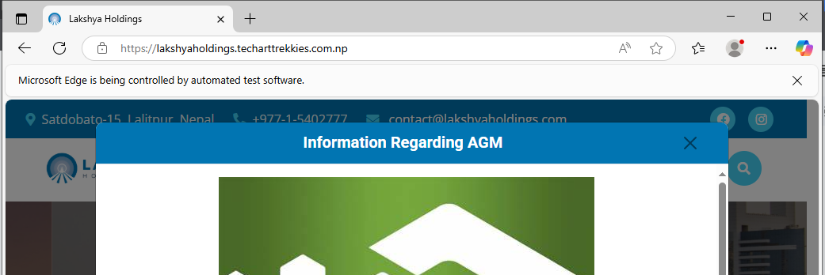

Fig: MSEdgeDriver

### Page Title

#### Code:

**import** org.openqa.selenium.chrome.ChromeDriver;

**public** **class** PageTitle {

**public** **static** **void** main(String[] args) {

ChromeDriver driver = **new** ChromeDriver();

**try** {

driver.get("https://lakshyaholdings.techarttrekkies.com.np/");

String pageTitle = driver.getTitle();

System.***out***.println("Page Title: " + pageTitle);

Thread.*sleep*(3000);

} **catch** (InterruptedException e) {

e.printStackTrace();

} **finally** {

driver.quit();

}

}

}

#### Output:

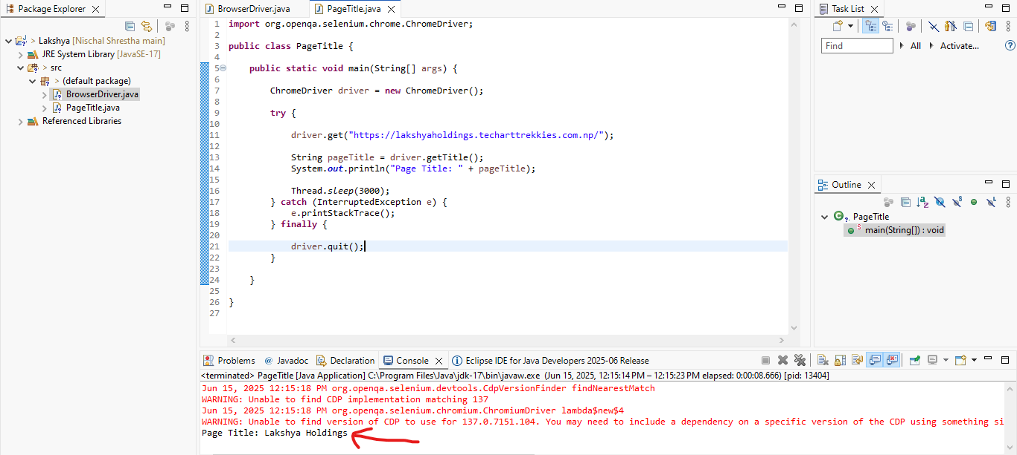

Fig: Page Title Output

### Navbar Navigation

#### Code:

**import** org.openqa.selenium.By;

**import** org.openqa.selenium.WebDriver;

**import** org.openqa.selenium.WebElement;

**import** org.openqa.selenium.chrome.ChromeDriver;

**import** org.openqa.selenium.support.ui.ExpectedConditions;

**import** org.openqa.selenium.support.ui.WebDriverWait;

**import** java.time.Duration;

**public** **class** NavbarNavigation {

**public** **static** **void** main(String[] args) {

WebDriver driver = **new** ChromeDriver();

// You can keep the WebDriverWait for critical waits, but add Thread.sleep for visual pauses.

WebDriverWait wait = **new** WebDriverWait(driver, Duration.*ofSeconds*(30));

driver.manage().window().maximize();

driver.navigate().to("https://lakshyaholdings.techarttrekkies.com.np/");

System.***out***.println("Visited Lakshya Holdings");

**try** {

Thread.*sleep*(1000);

} **catch** (InterruptedException e) {

Thread.*currentThread*().interrupt();

System.***err***.println("Thread was interrupted during sleep.");

}

**try** {

WebElement closeButton = wait.until(ExpectedConditions.*elementToBeClickable*(By.*className*("btn-close")));

**try** {

Thread.*sleep*(1000);

} **catch** (InterruptedException e) {

Thread.*currentThread*().interrupt();

System.***err***.println("Thread was interrupted during sleep.");

}

closeButton.click();

System.***out***.println("Popup close button clicked successfully.");

wait.until(ExpectedConditions.*invisibilityOfElementLocated*(By.*className*("btn-close")));

System.***out***.println("Popup is no longer visible.");

**try** {

Thread.*sleep*(1000);

} **catch** (InterruptedException e) {

Thread.*currentThread*().interrupt();

System.***err***.println("Thread was interrupted during sleep.");

}

} **catch** (Exception e) {

System.***out***.println("No popup detected or failed to close popup: " + e.getMessage());

}

WebElement noticesLink = wait.until(ExpectedConditions.*elementToBeClickable*(By.*linkText*("Notices")));

**try** {

Thread.*sleep*(1000);

} **catch** (InterruptedException e) {

Thread.*currentThread*().interrupt();

System.***err***.println("Thread was interrupted during sleep.");

}

noticesLink.click();

System.***out***.println("Clicked on Notices link present on Navbar");

wait.until(ExpectedConditions.*urlContains*("notices"));

System.***out***.println("Navigated to Notices page.");

**try** {

Thread.*sleep*(1500);

} **catch** (InterruptedException e) {

Thread.*currentThread*().interrupt();

System.***err***.println("Thread was interrupted during sleep.");

}

driver.navigate().back();

System.***out***.println("Back to Home page of Lakshya Holdings");

wait.until(ExpectedConditions.*urlToBe*("https://lakshyaholdings.techarttrekkies.com.np/"));

**try** {

Thread.*sleep*(1000);

} **catch** (InterruptedException e) {

Thread.*currentThread*().interrupt();

System.***err***.println("Thread was interrupted during sleep.");

}

driver.navigate().refresh();

System.***out***.println("Refreshed the current web page");

**try** {

Thread.*sleep*(1000);

} **catch** (InterruptedException e) {

Thread.*currentThread*().interrupt();

System.***err***.println("Thread was interrupted during sleep.");

}

driver.close();

System.***out***.println("Browser closed");

}

}

#### Output:

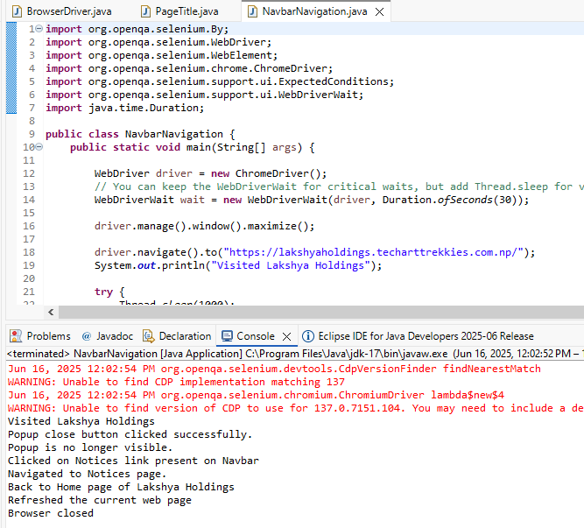

Fig: Navbar Navigation

1. Sadf
2. Sadf
3. sdaf